Affine transformation matrix in 2d and 3d

An **affine transformation** is a linear mapping method that preserves **points, straight lines, and planes**. Common operations like **rotation, scaling, translation, shearing**, and **reflection** are all affine transformations.

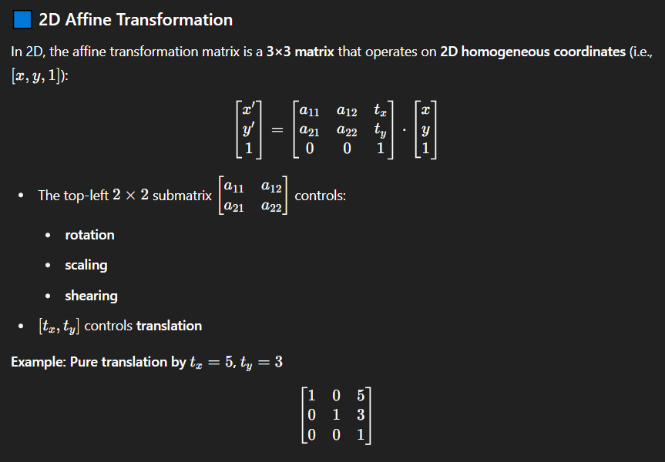

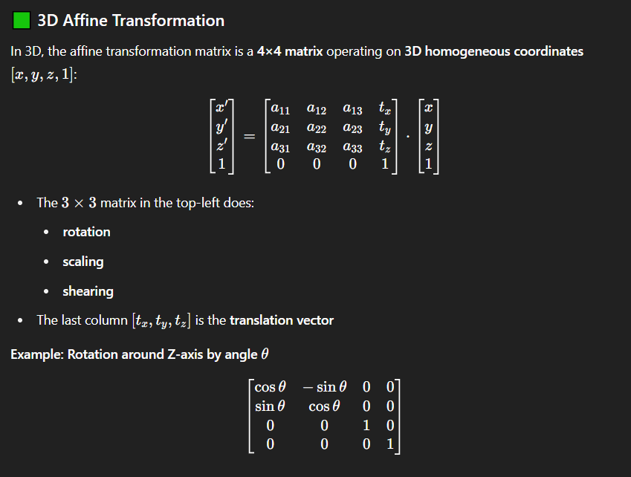

**🔷 What Are Homogeneous Coordinates?**

Homogeneous coordinates add an extra coordinate (usually a 1) to your point so you can perform **affine transformations** (like translation) using matrix multiplication.

* **2D point** (x,y)(x, y) → **Homogeneous**: (x,y,1)(x, y, 1)
* **3D point** (x,y,z)(x, y, z) → **Homogeneous**: (x,y,z,1)(x, y, z, 1)

You can think of this as embedding your space (2D or 3D) into a **higher-dimensional space**.

**🟢 Why Use Homogeneous Coordinates?**

Because it allows us to write **translation, rotation, scaling, and perspective projection** all as matrix multiplications. Without this, translations would require vector addition, which can't be unified into one matrix form.

**🔄 Dehomogenization**

After transformation, you can get back to normal coordinates by dividing by the last coordinate if it’s not 1:



But for most affine transformations, w stays 1, so you don’t need to worry about it.

**🟨 Summary**

| **Term** | **Meaning in This Context** |
| --- | --- |
| Homogeneous Point | A regular point with an extra coordinate (e.g. (x,y,1)(x, y, 1)) |
| Purpose | To perform all transformations (including translation) via matrix multiplication |
| Extra Benefit | Enables perspective projections in 3D rendering |